CDA 3103 Computer Organization Homework

**Section I: Problems**

1. (10 points) Construct true tables for the following XOR and XNOR gates.

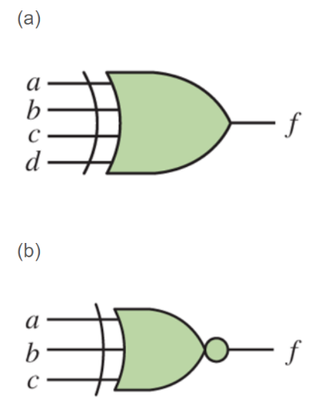

1. (10 Points) Write the Boolean expression in Canonical sum-of-products and Canonical product-of-sum forms for the following truth table.

|  |  |  |  |
| --- | --- | --- | --- |
| *x* | *y* | *z* | *F* |
| 0 | 0 | 0 | 1 |
| 0 | 0 | 1 | 1 |
| 0 | 1 | 0 | 0 |
| 0 | 1 | 1 | 1 |
| 1 | 0 | 0 | 1 |
| 1 | 0 | 1 | 0 |
| 1 | 1 | 0 | 0 |
| 1 | 1 | 1 | 1 |

1. (10 points) Use Boolean Identities to simplify the Canonical sum-of-product Boolean function obtained in problem 2.
2. (10 Points) Write the Boolean expression in Canonical sum-of-products and Canonical product-of-sum forms for the following truth table.

|  |  |  |  |  |
| --- | --- | --- | --- | --- |
| *w* | *x* | *y* | *z* | *F* |
| 0 | 0 | 0 | 0 | 1 |
| 0 | 0 | 0 | 1 | 1 |
| 0 | 0 | 1 | 0 | 0 |
| 0 | 0 | 1 | 1 | 1 |
| 0 | 1 | 0 | 0 | 1 |
| 0 | 1 | 0 | 1 | 0 |
| 0 | 1 | 1 | 0 | 0 |
| 0 | 1 | 1 | 1 | 1 |
| 1 | 0 | 0 | 0 | 1 |
| 1 | 0 | 0 | 1 | 0 |
| 1 | 0 | 1 | 0 | 0 |
| 1 | 0 | 1 | 1 | 0 |
| 1 | 1 | 0 | 0 | 1 |
| 1 | 1 | 0 | 1 | 1 |
| 1 | 1 | 1 | 0 | 0 |
| 1 | 1 | 1 | 1 | 0 |

1. (10 points) Use Boolean Identities to simplify the Canonical sum-of-product Boolean function obtained in problem 4.
2. (10 points) find CSOP and CPOS forms for the following functions:
$F\left(a,b,c\right)= ab+a'c$

$F\left(A, B, C, D\right)=A\left(B^{'}+CD^{'}\right)+A'BC'D$

3. (40 Points) Use Boolean Identities to simplify the following Boolean functions:

$xyz’ + xy’z’ + x’yz+x’y’z’+xyz$

$wxy'z+wxyz’+wxy’z’+wx’yz+wx’y’z+wx’y’z’+w’xy’z+w’x’yz+w’x’yz’$

$w^{'}x^{'}y^{'}+w^{'}xz+wxz+wx'y'z'$

$(X+Y+Z+W')(V+X)(V^{'}+Y+Z+W^{'})$

**Section II: Submission Requirements**

The following requirements are for electronic submission via Canvas.

* Your solutions must be in a single file with a file name yourname-module3-assignment-1.
* Upload the file by following the link where you download the homework description on Canvas.
* If scanned from hand-written copies, then the writing must be legible, or loss of credits may occur.
* Only submissions via the link on Canvas where this description is downloaded are graded. Submissions to any other locations on Canvas will be ignored.